1

Welcome to

Personal Computing

Professional Business Computing

Objectives
By the end of this chapter, you should be able to:
- Discuss how information technology (IT) changes permit innovations.
- Distinguish between technological change and business innovation.
- Explain differences between personal computing and professional business computing (PBC).
- Approach simple business situations using systems thinking.
- Distinguish among the major types of organizational systems and the information systems that are embedded in them.
- Consider the information systems (IS) major

Introduction
In your lifetime, technology has revolutionized the world, and it includes business. Just think about the apps and other new products that didn’t exist before you began college. At a much broader level, whole industries are in turmoil. Many people have already “cut the cord” on cable television, watching television exclusively over the Internet. They are also using their mobile phones to deliver television and movies, skipping a cabled connection completely. This is not just an embryonic change. Netflix already accounts for more than a third of all the traffic going to American homes during prime time. Home Box Office, which pioneered pay television on the new medium of cable TV in 1970s, expanded to the Internet in 2015.
Rapid change is also taking place inside the walls of corporations. Companies today must move faster, drive down costs, and become more innovative every year if they want to be competitive. These changes are not all due to technology, but information technology (IT) has certainly become a major enabler of change. Companies that do not embrace the possibilities created by ever-changing IT will have a perilous future compared to those that do.
Figure 1-1: A Recent Timeline for IT-Based Products
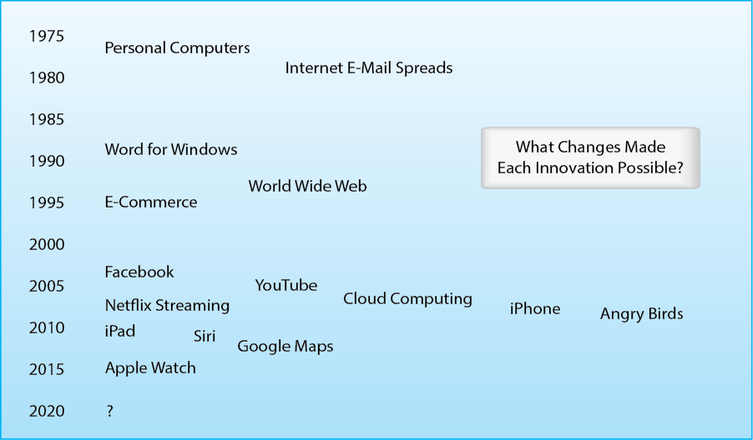
Technology, however, never changes anything. Technology merely makes change possible. People with vision and hard work exploit the possibilities created by IT. These people work in entrepreneurial startups, corporate IT departments, and every corner of every firm. They work in major departments such as marketing, sales, accounting, and finance. They also work in the many smaller departments in the firm, such as the department that manages insurance policies on its buildings. In fact, it is in the smallest corners of the firm where innovation often flourishes the most fully. Individual managers and professionals have goals that can be reached better with information technology, and teams that exploit technology may accomplish far more than they could before.
Technology never changes anything.

Figure 1-2: Technology and Innovation
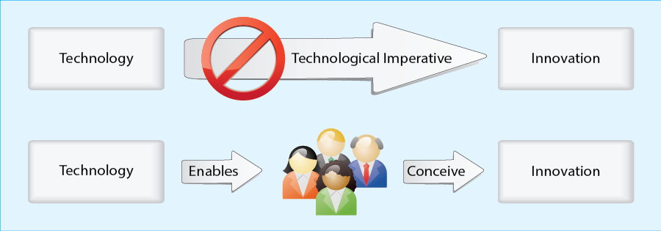
Even information technology that is not new changes constantly. Hardware prices fall, processing power increases, new ways to interact become possible, and networking makes everything available more of the time, in more places, and with more speed. Innovators must anticipate what will be possible tomorrow, not just today. When they look at mobile phones, for example, they need to ask what they will be able to do in a few years, not just what they can do today. Figure 1-3 shows some of the many areas in which technology is likely to change mobile phones in the near future. Note that these changes include not only computer technology but also materials sciences technologies, such as better screens.
Figure 1-3: The Pace of Change in Mobile Phones
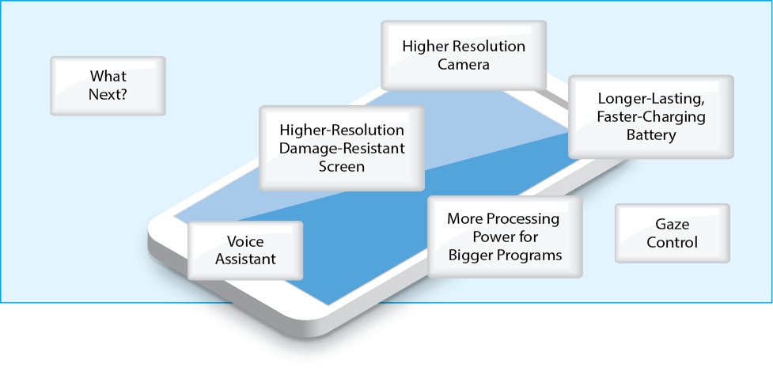
Innovation is nothing new in business. It has always been the key to maintaining and increasing market share and profitability. Many innovations, even today, have nothing to do with technology. However, technology is changing more rapidly than anything else, and change tends to create opportunities for innovation. Innovations, however, are always business innovations, not technology innovations. They change the way we do marketing, new product development, manage human resources, and do the myriad other things we do in organizations. Innovation exploiting IT is a skill for business students, not computer scientists.
Innovation is laborious process. It starts with insight. What is possible and how can we leverage new technologies to work better? Coming across a great idea is exhilarating. It is also about one percent of the job.
Next, the innovator must flesh out the nature and consequences of the possible change. What will people have to do differently? How will their relative roles and relationships change? What will the budget need to be? Who will get the benefits, and who will pay the costs? What privacy, security, and other business issues must be addressed, and how can they be handled? Now, two percent of the work is done.
The rest is getting everyone to buy into the change, learning the technology, designing the details, putting the changed work system into place, testing it, refining it, and managing it as long as it remains in use. As Peter Drucker so eloquently said, “in the end, everything must degenerate into work.” Innovation is not for timid. Neither is business in general.
Your first job title will not be chief executive officer. Initially, you will be a small part of fairly small projects. However, these projects are good incubators for effective business professionals. In this cottage-sized world, you will learn how innovation is done. Even in the smallest role, you will be working to make your own performance better. You will be learning the craft of innovation in business computing.
In this course, you will learn the concepts and practices you will need to exploit technology in business. You may even find yourself drawn to the center of gravity of corporate computing—the IT department that manages, supports, and enhances corporate information technology.
Reflection
1. Pick one new product in Figure 1-1. Spend about five minutes attempting to identify the hardware, software, transmission, business, and societal advances that were needed for it to be possible and that were not ready even a year or two earlier.
2 A little more research. Facebook was preceded by a similar product, Myspace. Do a little Internet sear to see why Facebook succeeded while Myspace did not. How does this relate to the idea that there is no inevitable technological imperative driving product innovation when technology makes new things possible?

From Personal Computing to Business Computing
You already know a lot about computing. Why do you need another IT course? The answer lies in the difference between personal computing and business computing.

Primary (Personal) Flight Training
A historical example may help you understand the difference. In World War II, American pilots went through several stages of training. Primary was the stage when they first learned to fly. They took off, flew around, and landed—first with an instructor pilot and then flying solo. They learned to manage their engines, recover from spins, and deal with nearby traffic. These are the things every private pilot must know. Recognizing this, the U.S. Army Air Forces outsourced Primary to civilian flight training schools already in existence. Given the shortage of pilots the U.S. had before World War II, outsourcing was critical for training the large numbers of military pilots the country would need. Outsourcing was possible because Primary taught personal flying and so did not require military pilots to teach it.
Figure 1-4: Primary Pilot Training in World War II
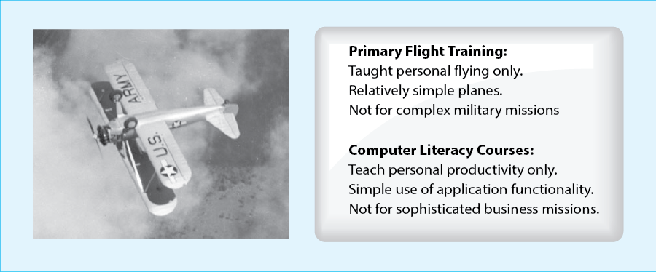

Military Flight Training
After Primary, training taught military flying. Using more complex and higher-performance aircraft, cadets learned the more demanding skills they would need to carry out military missions. They learned to manage more demanding aircraft controls. They learned long-distance nighttime navigation and how to deal with complex air-ground communication. They learned team coordination, including close-formation flying. They also learned the kinds of defensive flying they would need to survive. Of course, they learned gunnery and bombing, but these were merely two of the many skills needed to carry out long, complex missions.
Figure 1-5: Advanced Training for Military Flying
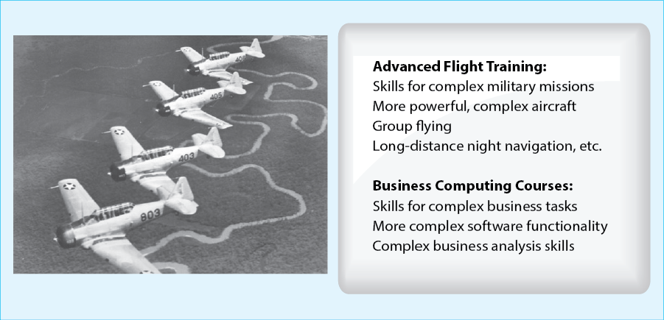

Personal versus Professional Business Computing
In a similar vein, your computer literacy class taught you how to do personal computing in your private life. Projects were selected for personal life needs, including working with social media. You leaned the functions in these programs that you need in your personal life. In business, however, you will face bigger challenges using information technology (IT). Most obviously, you will use spreadsheets to build large models of business situations. This will require a highly disciplined development process involving assessing requirements and scope, designing your logic to fit on flat pages, creating the model efficiently and effectively, testing it rigorously, interpreting the results, trying out different scenarios for what might happen in the future, and documenting the model for someone else to use it after you are promoted or assigned to another business unit. You will need to develop the business computing skills to do this and many other large, business-specific tasks.

Analytical Modeling Skills
While student pilots in World War II had to work with progressively more demanding aircraft, spreadsheet programs can span the needs of everyone from novices to business professionals. There are myriad advanced features in spreadsheet programs that can make a model sing with capability. You must understand these features to be effective. However, the goal is not to learn more spreadsheet features. The goal is to learn what you need to approach complex business situations with sophisticated business computing. You must understand how you can use advanced features to achieve complex goals. In what-if analysis, for example, you modify your model to reflect different conditions a firm is likely to encounter. You will learn how to do this in a specific spreadsheet program, but the software skills you will learn will be small compared to the business skills you will learn to do it well.
The goal is not to learn more spreadsheet features. The goal is to learn what you need to approach complex business situations with sophisticated business computing.

Teamwork Communication
You already do social networking. This is a form of group computing, but it is a very personal style of group interaction. In organizations, you will spend a great deal of time communicating with team members, and the communication needs to be disciplined to allow you to deal with tight schedules and the need to depend on others in complex group tasks such as evaluating a business opportunity or developing a new product. You will need to manage this communication across e-mail, group meetings, meetings with two or three others, phone communication, and video communication, among other new modalities for interaction. You will also need to retrieve relevant information successfully and quickly, regardless of the tool that was used to deliver it.
Figure 1-6: Personal Computing and Business Computing
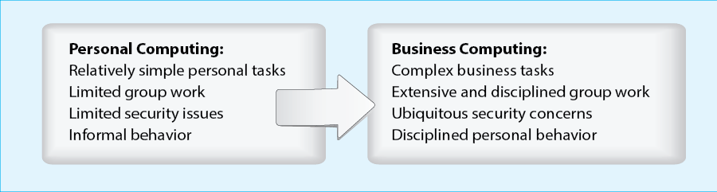

Pervasive Security Concerns
Finally, security is the snake in the IT garden. Security is a concern in personal computing, but in corporate computing, it is paramount. If you build business models, they are important trade secrets that can be stolen by competitors. If you fall for ransomware by opening an attachment that encrypts all your files, you stall important projects. More broadly, enormous break-ins, in which millions of credit cards are stolen, typically begin when a business professional accidentally gives an attacker a foothold in the organization, say by clicking on an e-mail link. Working with private customer information and employee information is a minefield, and a single accidental exposure of personally identifiable information can literally cost millions or hundreds of millions of dollars.

Privacy in Communication
Outside of business, social media has led to harassment, cyberstalking, cyberbullying, and other abuses. These happen in business as well. However, businesses have no hesitation in dealing with them. Simply from the economic point of view, businesses clamp down on them because the business can be sued for what its employees do to one another. Business computing is never private, and the sanctions for abuse are steep. Telling off-color jokes in meetings or by e-mail is very likely to get one fired.

Personal versus Business Behavior
Business behavior in general tends to be different from personal behavior. Many students have their phones out during class to text friends, check Facebook, or kill pigs with avian missiles. In business, this is not tolerated. Neither is failing to respond to e-mail promptly or missing deadlines. In fact, your personal use of tools like Facebook may need to change. Disparaging your boss or company or giving out information about business projects and products are grounds for being fired. Business discipline is not military discipline, but it is neither ambiguous nor forgiving. Developing and maintaining a good reputation is critical for success or even keeping a job after you are hired.
In the end, business computing is like personal computing in terms of computer skills. You simply learn more functionality. However, business computing is nothing like personal computing in terms of what you will do and how you must do it. Businesses are professional organizations, and being a professional involves both discipline and the ability to work effectively, including the ability to innovate.
Reflection
3. Summarize arguments about why your knowledge of spreadsheet development is not sufficient for the tasks you will do in business.

Systems
A central unifying idea in IT innovation is a concept of systems. A system is a group of components that act together to achieve goals. For instance, the marketing department is a system. Its components include people, information technology, office space, and many other things. An online order entry system is another system with many human and technological parts that must work together closely to function properly.

Human Systems
Systems Thinking is a central concept that must always drive thinking when dealing with change. Consider a nontechnical system, American football. (This is the type of football that rarely involves feet touching the ball.) There are eleven players on a side. They execute complex plays that involve intricate patterns of initial position, motion, and violence. The coach designs plays and adjust minute features such as how far apart the offensive linemen should be. If the team has an outstanding drop-back quarterback for passing, the coach will move the linemen close together for better pass protection and place more receivers in the pattern down field. The coach will then run practices and make changes to fine-tune the system.
Figure 1-7: A Human System: American Football
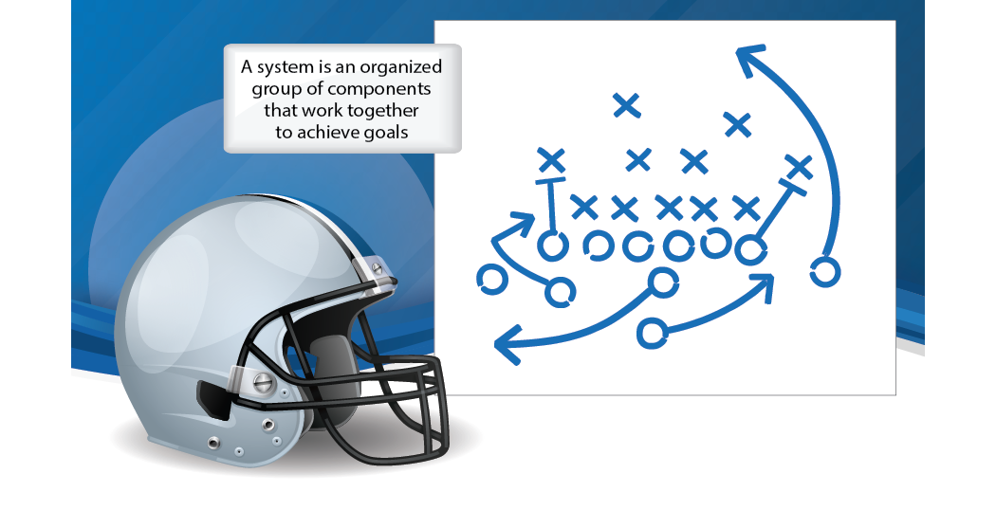
Every element is important. If a running back whose job on a play is to protect the passer misses a block, the play ends in tears. Although quarterbacks are exceptionally important in achieving success, every part off the system is important and must be designed properly, integrated into the other pieces, and managed afterward in a messy world.
Systems thinking is important because it allows us to conceptualize how to respond to change. Suppose that a star quarterback moves to another team. This is a major loss, but suppose that the team acquires a pair of excellent running backs during the off season. When components change, one option is always to keep the system constant. The team could run the same plays and keep the distances between linemen the same. Of course, that would not be a good idea. New plays are needed to take advantage of the new running back pair, the space between linemen should be widened to create more lanes for running, two tight ends might be used for added blocking, and may many other changes may be needed. When a central element of a system changes, it almost always makes sense to redesign the system.
The parts of systems that are changing the most rapidly represent both the greatest threats and the greatest enablers of positive change. Today, technology is important primarily because it is the most rapidly changing part of most business systems. More specifically, technology change tends to expand what people can do with their brains, and this is a great seed for positive change.
Again, however, technological change never forces or causes innovation. Without human insight into what new ways of working a technological change makes possible and the commitment to achieve these possibilities, technology brings little benefit. In fact, it is likely to merely raise costs and may even do harm. Unmanaged technological change becomes a Frankenstein’s monster. Technology produces no benefits. Business professionals exploiut technological changes to produce benefits.
Reflection
4. Describe the components of a different human system and how responding to a particular change may require changing the system.

Technology-Based Systems
Figure 1-8 shows a complex organizational system. We will look at a few of its components in this chapter. We will look at this figure in more detail in later chapters.
Figure 1-8: An Organizational System
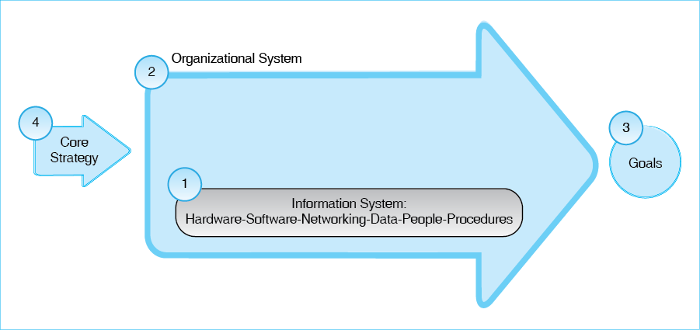

Information Systems
Traditionally, technologists focused on small parts of businesses called information systems. These are the specialized information-handling parts of organizational systems. They obviously consist of computers, software, networks, and data. Beyond technology they also have human components. For example, a payroll processing information system needs people to run the technology and collect data, as well procedures for such things as collecting data from individual departments, handling exceptions, and managing the overall information systems. To paraphrase what Ben Schneier has said about security, “If you think technology can solve your business problems, then you don't understand the business and you don't understand the technology.”
“If you think technology can solve your business problems, then you don't understand business and you don't understand technology”

Organizational Systems
Although information systems are important in and of themselves, Figure 1-8 shows that they are always embedded in larger organizational systems. In systems terminology, an information system is a subsystem within a broader organizational system. Payroll processing information systems may be centered in the human resources department, which is an organizational system. In the case of payroll processing and human resources, the distinction between information systems and the organizational system is clear. In other organizational systems, technology and process are so interwoven that the distinction between the two is not a useful one.
Entire organizations are systems. So are individual functions and departments. So are small project teams, and so are inter-organizational systems that extending from manufacturers through wholesalers to retailers. We will use the generic term organizational system (OS) to refer to all of these systems.
Reflection
5. Why is e-mail an information system and not an organizational system?

Goals
Every organizational system has goals. Accomplishing these goals is the only reason for an organizational system to exist. In an organization, goals nearly always exist to make another part of the firm work better. They are goals such as making another part off the firm more efficient, more effective (in meeting its own goals), faster, more agile in adjusting to changes, less exposed to cyber risk, and so forth. If a system does not have clear goals, it is not likely to succeed regardless of how well everything else is done in the system.

Core Strategies
To achieve goals, organizational systems need strategies for organizing the resources of the system to achieve the system’s goal in the best way possible. For example, there may be an accounts payables department in which several people with different information might review the invoice sequentially. Others might be charged with reviewing and authorizing payments. There would typically be a delay between each person, and paying a single invoice might take hours of time spread over weeks.
Figure 1-9: Accounts Payable Core Strategy
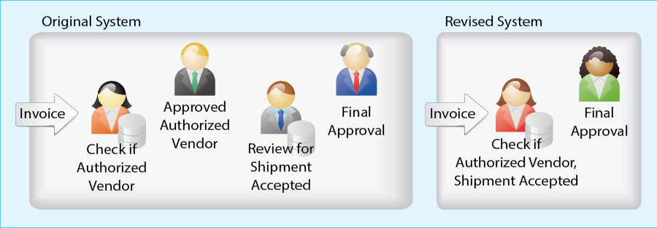
With a better information system, one person might have all of the information needed to evaluate a transaction. After the review is done, the information might be automatically routed to a single person who can authorize the payment after scrutinizing the analysis. This system could reduce cost and shorten payment cycles. In many cases, there is a discount if the firm pays within a certain period of time. Faster action might enable to the firm to reduce the cost of each payment.
Strategies can be complex, but they are usually based on a core strategy that is simple and highly targeted. For example, for the accounts receivable process, the core strategy is to simplify invoice payments decisions by having a single person review each invoice based on multiple pieces of information and having a single person authorize the review’s decision if appropriate. The strategy will contain far more detail to flesh out the core strategy. However, a clear core strategy in necessary to give guidance for all of the details of the strategy and to guide implementation.
Reflection
6. What are your goals in this course? What are your core strategies for achieving them?

Examples of Organizational Systems
As noted earlier, organizational systems come in many different sizes. We will look at a few of the most important now. We will see them in more depth in later channels.

Individual Employees
Even individuals can be analyzed as organizational systems. As an employee, you will certainly have goals and strategies. You will also use information technology within your work processes for achieving these goals. Therefore, you will need skills in applying these information systems to specific problem-solving activities from you first day on the job.
You probably have never thought of yourself as an organizational system, but individuals are at the heart of every larger organizational system. In addition, you will be a very expensive organizational system when you get a professional job. Suppose that you get paid $50,000 per year. To that, companies must add the cost of health and other benefits, holidays, vacation time, the cost of managers to manage you, the cafeteria, maintenance, and other overhead costs. In round numbers, you will cost about $100,000 per year. Companies want their money’s worth, and you will need all the help you can get to deliver it.
You will see many of the same applications in business that you see in your personal life. For example, you now use a spreadsheet application and will continue to do so. You will also continue to use e-mail and many other tools. However, as noted earlier, business applications tend to require greater skill to use than personal applications. In spreadsheets, the differences will primarily be in the size and complexity of your spreadsheet models and in the functionality you will need to create these big complicated models.
In other applications, such as e-mail, the mail applications you encounter in business will be group-oriented. Corporate mail systems are structured to allow group messages to be organized for later retrieval. Information on the same topic can be stored together so that information on a particular issue can be reviewed quickly. In addition, a project team member can search the entire corpus of the project’s team mail by topic or text string. The first of these systems was actually created in the 1960s. It was used in Stanford Research Institute’s Augmentation Research Center to document the development of the world’s first working hypertext system, NLS. This organized mail system was called, simply, the Journal System.
Figure 1-10: Project Team E-Mail
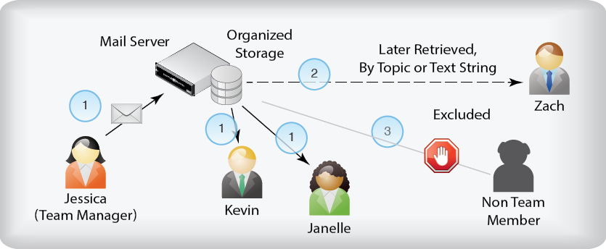
One business skill you will need to master is the analysis of business opportunities. As Figure 1-11 shows, business decisions often have many components. These need to be brought together into a model, typically on a spreadsheet. Just building the model can produce insights into what is important and what needs to be considered to evaluate a particular business opportunity. These insights will require you to refine the model as your understanding increases. Modeling is a complex craft that goes far beyond mastering spreadsheet functionality.
Figure 1-11: Business Analysis
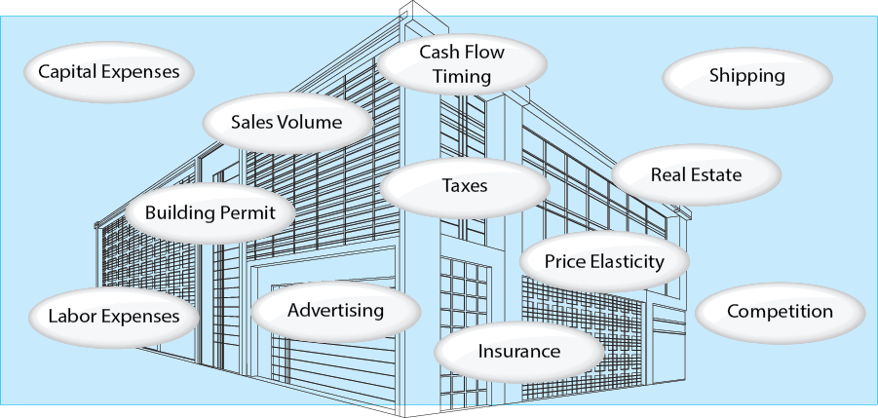
Reflection
7. Create a model for a personal budget. Do it on a spreadsheet. Fill in rough numbers for different spending categories. You never want to run out of cash, of course. Suppose that you start with $1,500. For two semester, figure out, based on these really tentative numbers, how much cash you will have to get through loans, work, or parents.

Functional Departments
You will always be working on larger units, beginning with your functional department, such as marketing, accounting, shipping, or IT. Each functional department, of course, needs information systems specific to its specific needs. Figure 1-12 shows that corporations have many functional departments with very different needs for information systems. For example, in a sales department, there will be a customer relationship management (CRM) system to help salespeople collect all data for individual customers into readily-accessible information that can be used piece-by-piece or analyzed statistically. Human resources will have software to track new employees through the multi-step hiring process. Other functional departments will do very different work and therefore will have very different technology support.
Figure 1-12: Functional Departments
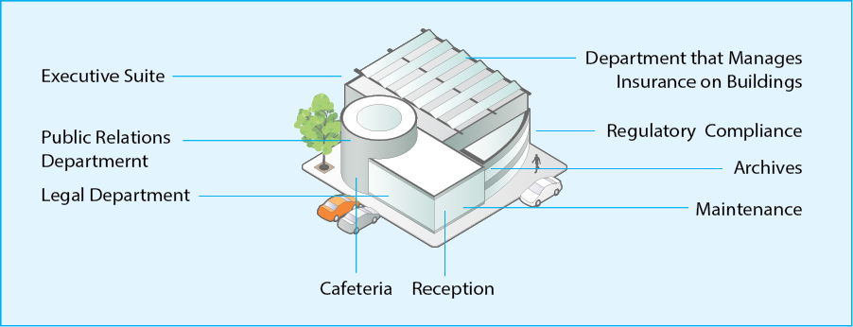
In addition to these “big” information systems in functional departments, department employees will often work with many other systems. They will build spreadsheet models that often draw little information from bigger functional or enterprise information systems. In addition, of course, they will all use e-mail and telephones. Functional department information systems are not the only information systems used in functional departments.
Reflection
8. Why do different functional departments need different information systems? (This is not a trick question.) Functional departments use big information systems and smaller information systems. Which of these do you think the corporate IT department knows about and understands?

Enterprise Systems
The biggest system in an organization is the organization itself. Organizations are unbelievably complex when considered in detail. However, it is useful to think about the key business functions that execute the high-volume core transactions of the firm’s main workflow. These are called enterprise systems. Figure 1-13 shows major enterprise systems in a manufacturing firm. Different functional departments handle the procurement of raw materials and subassemblies, the management of the received inventory, production, warehouse storage for finished products, and shipping. Other functions connect into this workflow. Obviously, some department must accept orders. Accounting, of course, is involved in every step of the process.
Figure 1-13: Enterprise Systems
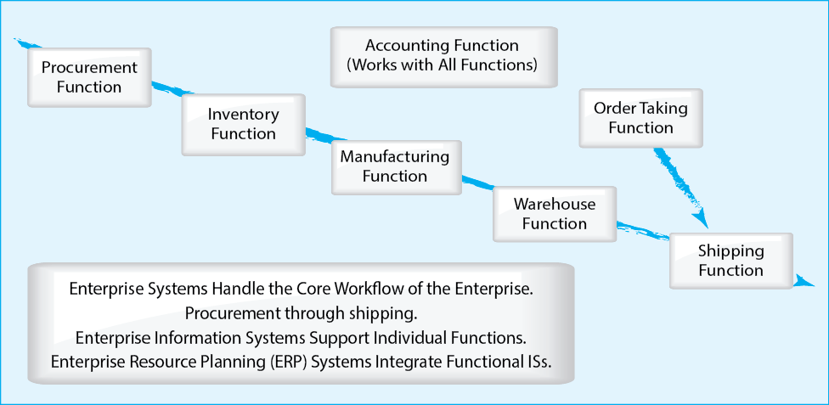
Although individual departments need their own functional systems, enterprise information systems must connect these departmental systems together. Obviously, the order taking department must send orders to shipping, which retrieves the correct items from the warehouse. This order must also go to procurement and inventory so that its contents can be added to goods to be replenished. Nearly every transaction must be copied to accounting for processing. A number of companies supply enterprise information systems with integrated modules to fit the major enterprise system functional departments. These systems are called enterprise resource planning (ERP) information systems. The name is outdated; ERP systems do far more than assist planning.
ERP systems form the central nervous system of the corporations. Thousands of transactions flow through them every hour. Information from these databases are highly structured. Figure 1-14, for example, shows a simplified table in a database for purchase orders sent out to suppliers. If there is a question about a particular transaction later, the information can be retrieved from the database. Functional departments other than purchasing can also access this database as needed.
Figure 1-14: Part of a Simplified Procurement Database
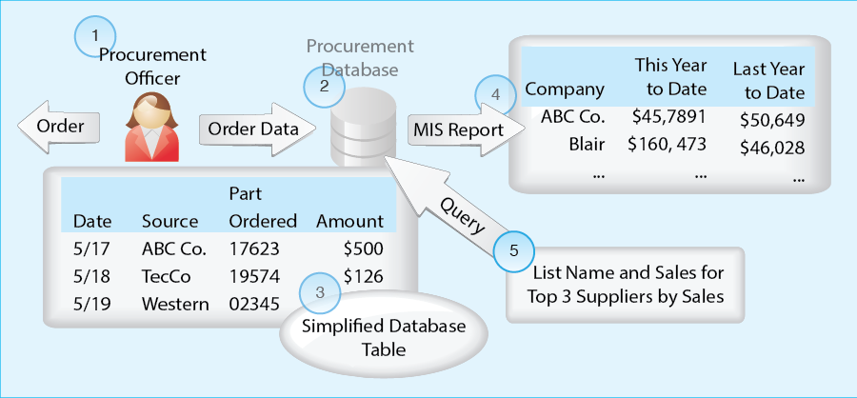
To manage the procurement function, analysts must look for patterns in the database information. Some patterns are obvious and ate the same every week or month. For these patterns, it is common to deliver periodic reports of the same information, so that changes can be tracked over time. These are like vital signs (heart rate, temperature, etc.) in medicine. They show whether the business function is healthy. These are called management information system (MIS) reports.
MIS reports are very useful, but they do not report on all patterns of potential interest. Query tools allow managers to ask specific questions about patterns in the database. For example, if collusion is suspected between a supplier and a procurement employee, the pattern of orders sent by that particular employee to that particular supplier might be queried. Most queries are ad hoc queries, meaning that they are done for specific reasons. They may never be done again.
Reflection
9. Introductory information systems courses tend to focus very heavily on enterprise systems rather than on information systems in smaller business units. Can you think of a reason why this might be the case? (Hint: introductory courses tend to focus heavily on the needs of majors rather than general business students.)
10. Databases like the one shown in Figure 1-14 are found in information systems of many types. Distinguish between databases, tables, MIS reports, and queries. In this table, what do individual rows represent? What do individual columns represent? What does information at the intersection of a specific row and column represent?

Interorganizational and Supply Chain Systems
The three levels of organizational systems that we have just seen (individual, functional department, and enterprise) are all inside an organization. Organizations also have externally-facing systems to deal with the outside world. Obviously, there is the Internet, including the World Wide Web. Large organizations who do business with each other frequently and in high volume use interorganizational systems to link them together. Beyond interorganizational systems, which connect pairs of firms, multiple interorganizational systems often form supply chain systems, which link buyers and sellers are various levels in the product creation and delivery hierarchy. Figure * shows a simplified supply chain.
Figure 1-15: Supply Chain Built from Multiple Interorganizational Systems
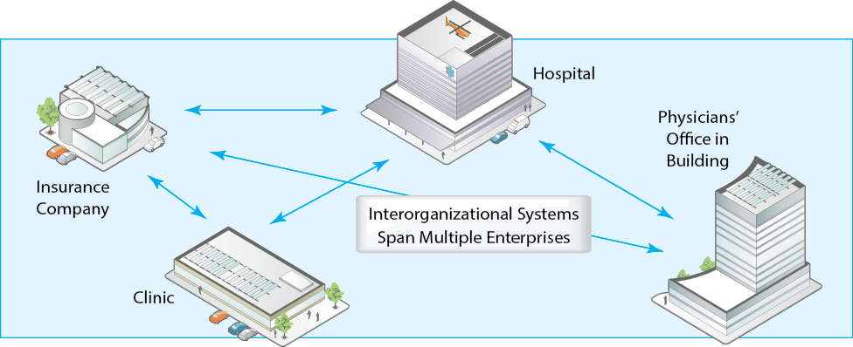
Reflection
11. Based on what you know, sketch out a supply chain system for the gasoline that reaches your car.

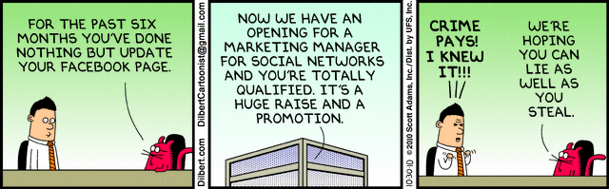
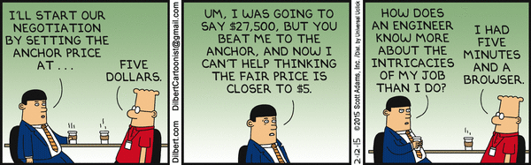
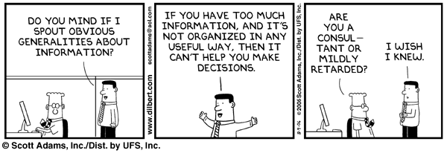
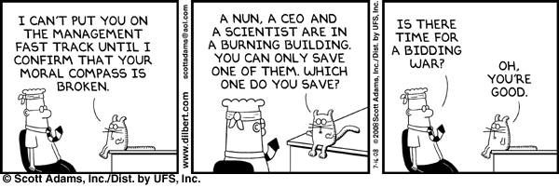

Reflection
12. The text mentioned opening e-mail attachments. How else can you unwittingly give criminals a foothold on your corporation’s network?
13. Do you think that company “spying” on their employees is fair? What surprised you in this section about company surveillance?

Careers in Business IT
If you want to write commercial software, computer science is the major for you. If you want to work in business with advanced information technology, you should think about majoring in information systems.

Corporate IT Departments
IS graduates work corporate IT departments. These departments help the corporation exploit the potential of IT. They manage the network and other infrastructure, they introduce complex new applications, they worry about security, they manage large projects, and they do all the other heavy technical lifting needed in the firm.
Figure 1-16: Information Systems Degrees versus Computer Science Degrees
 | Information Systems Degree | Computer Science Degree
Probable Employment | IT department in a corporation:  Help exploit technology  Manage the infrastructure  Introduce complex new applications  Handle security  Manage large projects | Software or hardware vendor
Technical Focus | Skills needed in pre preceding row  For example, designing a router-based network and configuring routers | Skills needed to create technology  For example, creating routers or routing algorithms for better router design
Business Education | High (full business degree) | Usually nonexistent
Career Prospects and Salary | High | Higher

Programming is Only Part
To work in IS, you will need to learn a good deal about IT. However, unlike computer science, programming will be a modest part of what most IS graduates do. They also need to learn about individual IT topics differences. In computer science networking courses, students are often taught how to build a router. (Routers are the switching engines that drive the Internet.) In corporate IT, however, professionals do not have to know how to build routers. They do, however, need to understand how to manage routers, how to use them to build large networks, and how to make them secure against cyberattacks. IS networking courses teach this. Teaching material that people in IT departments need to know is the differential advantage of IS programs.

Full Business Degree
Of equal importance, IS students get full business degrees. They need this broad business knowledge to work with projects in marketing, finance, accounting, human resources, and other specialized business units. They also learn from the first day that you never say, “Cost doesn’t matter.” Although they get less technology training than computer science majors, they get the right kind of training for business, and they develop the conceptual and practical skills they need to deal with business projects.

Job Variety
IT jobs are great jobs. Hiring rates for IS graduates have long been among the highest in business schools, and pay is excellent. You work with technology, but you spend a lot of time with people doing problem solving. Perhaps most importantly, IT professionals do not do the same thing day in and day out. Every project is new and challenging. Learning is constant. The repetitive work that blights many jobs is not an issue for job satisfaction. Consider that carefully when you pick a major. And, of course, you get to play with the newest and coolest toys.

Job Opportunity
Information Systems graduates have
Reflection
14. Comment on the statement that IS majors are not trained as well as computer science students.

Figure 1-1: A Recent Timeline for IT-Based Products 2
Figure 1-2: Technology and Innovation 3
Figure 1-3: The Pace of Change in Mobile Phones 3
Figure 1-4: Primary Pilot Training in World War II 5
Figure 1-5: Advanced Training for Military Flying 6
Figure 1-6: Personal Computing and Business Computing 7
Figure 1-7: A Human System: American Football 9
Figure 1-8: An Organizational System 10
Figure 1-9: Accounts Payable Core Strategy 12
Figure 1-10: Project Team E-Mail 13
Figure 1-11: Business Analysis 14
Figure 1-12: Functional Departments 15
Figure 1-13: Enterprise Systems 16
Figure 1-14: Part of a Simplified Procurement Database 17
Figure 1-15: Supply Chain Built from Multiple Interorganizational Systems 18
Figure 1-16: Information Systems Degrees versus Computer Science Degrees 19

Schneier, Ben, Secrets and Lies, New York: Wiley, 2000.

